DEEP SEA DISASTER
By elinor price DATE june 2023
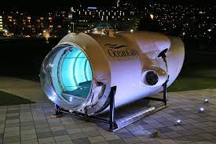

A different submersible owned by the parent company of the Titan.
Image from Wikimedia commons

Answer the following questions in full sentences:
- What is this news story about?
The implosion of a submersible due to the enormous pressure at the bottom of the sea.

- Compare the pressure at 3,800 metres below sea level with the pressure at sea level.
At 3,800 m below sea level, pressure is approximately 375 times greater than at sea level.

- Explain the difference between a submarine and a submersible.
A submarine can launch and return itself to port whereas a submersible requires a mothership to do this.

- Write down the meanings of any words in bold in the article.
Wreckage – the remains of something that has been damaged or destroyed
Catastrophic – involving sudden great damage
Implosion – an event where an object collapses inwards
Vessels – ships, boats or other objects that function to hold things within
Integrity – being whole, undivided or unbroken in construction

